Project Report: Electronic Vendor Database

Group Members

Introduction:

The application we developed, named **BBUY** is an electronics vendor that operates both a website and a chain of many physical stores. In our hypothetical company, it has been decided to redesign a major part of the database that underlies company operations. Here are a few points to consider based on which we have prepared the ER Diagram:

• There are many different products, grouped into a variety of categories. Groups can be formed by type of product (cameras, phones, etc.), by manufacturer (Sony, Apple, etc.), or by other means

• Some customers have a contract with the company and bill their purchases to an account number. They are billed monthly. Other customers are infrequent customers and pay with a credit or debit card. Card information may be stored for online customers, but not for in-store customers.

• Online sales must be sent to a shipper. The company needs to store the tracking number for the shipping company so it can respond to customer inquiries.

• Inventory must be accurate both in stores and in warehouses used to replenish stores and to ship to online customers. When inventory is low, a reorder should be sent to the manufacturer and listed in the database. When goods arrive, inventory should be updated, and reorders marked as having been filled.

• Sales data are important for corporate planning. Marketers may want to look at sales data by time period, product, product grouping, season, region (for stores), etc.

ER Diagram:

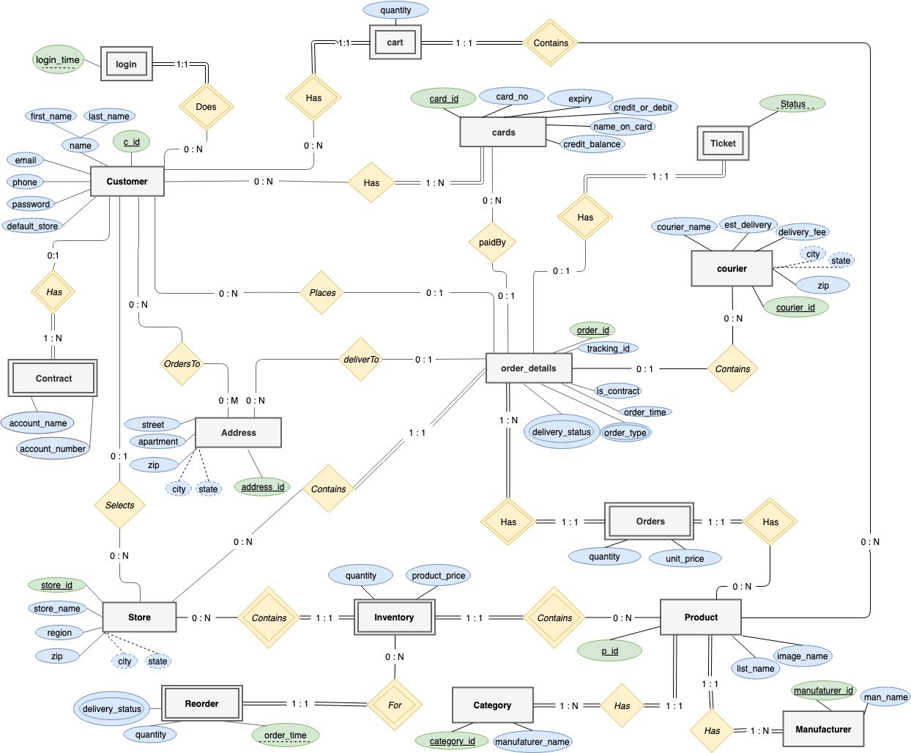

Relation DB:

The SQL queries related to the application can be found in the attached **“sql_scripts.sql”** file.

The queries are ordered as below:

1. Create Statements
2. Create Sequences
3. Create Triggers
4. Finally, the Insert statements

Additionally, the queries used for the dynamic loading and storing of data from the web-app are present in “**queries.php**” file in each source folder. Some queries are also directly embedded in the html page.

The server setup steps are present in “**server_steps.txt**”

Application Screenshot:

1. Log In page of the application:

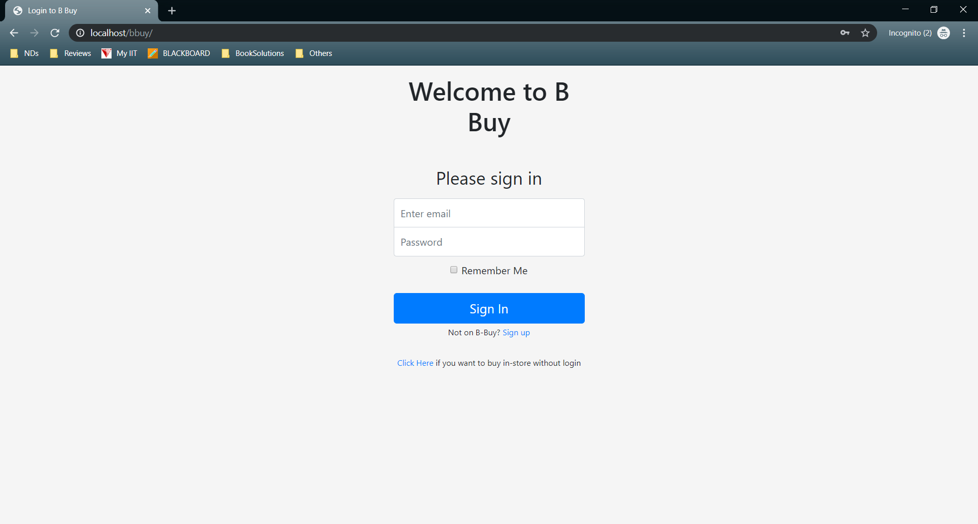

1. Suppose we are visiting the application for the first time and we do not have an account. We now have two options:
2. Buy in-store without creating an account:

Click on the “click Here” link as highlighted below:

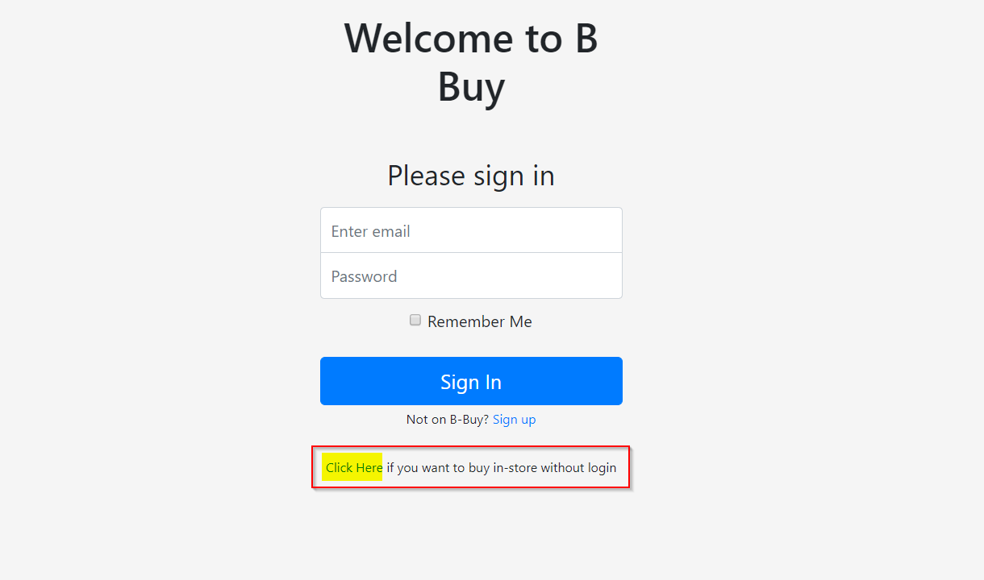

This will take us to the application home page:

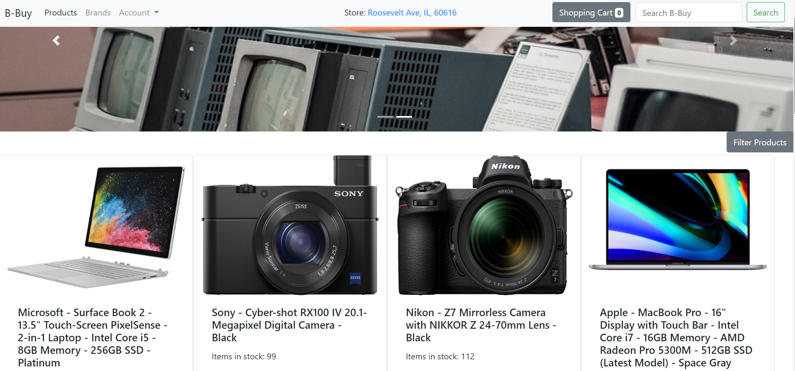

We can select a store from where we wish to Pick up our order. Selecting a store works by clicking on the store:



This provides us with options to select other available stores:

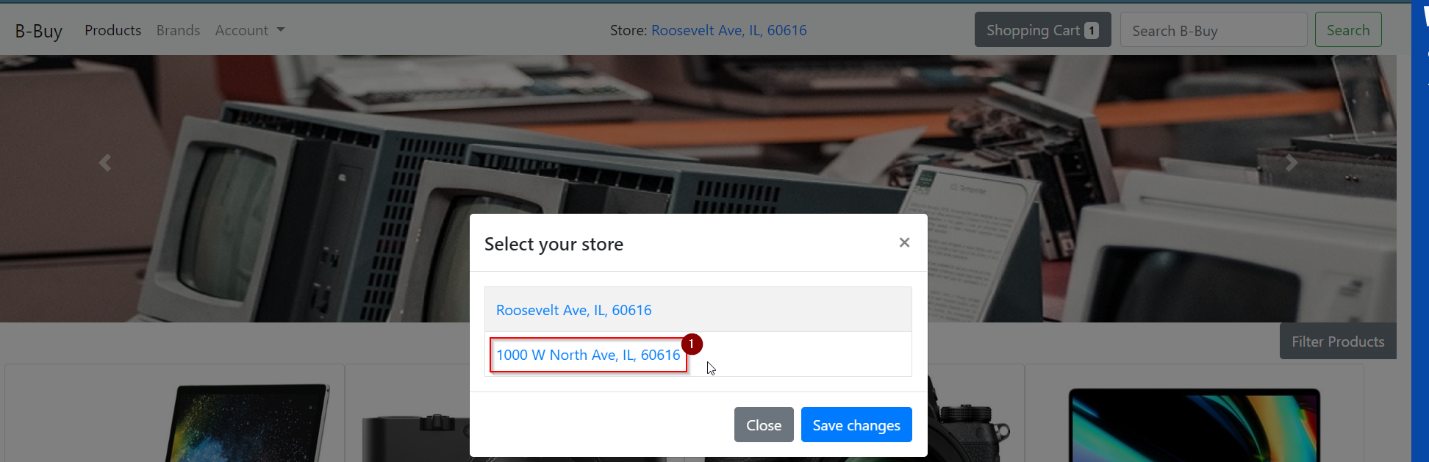

Clicking on a store sets the store as selected store and displays products available at that store:



We can add a product to card by clicking “Add to Cart” button below each product and then click on the Cart icon to move to checkout page:

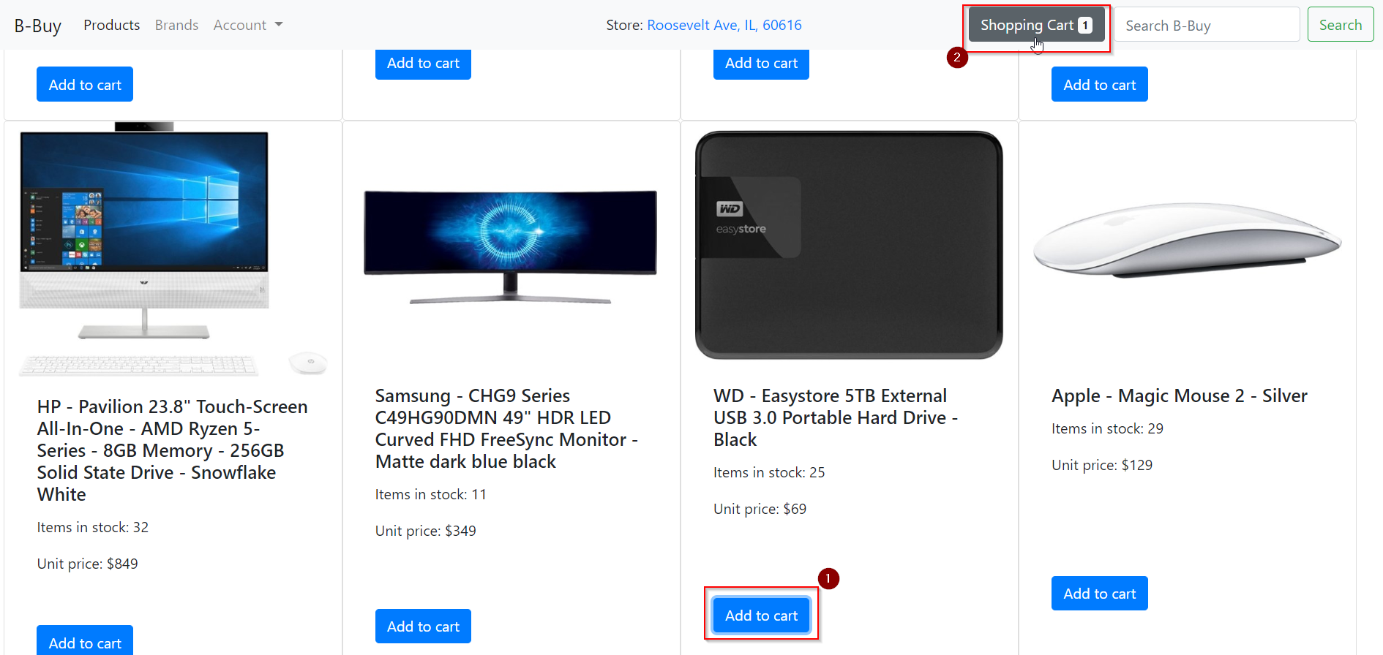

The checkout page shows us the quantity selected, available items in inventory and total price of items in cart.

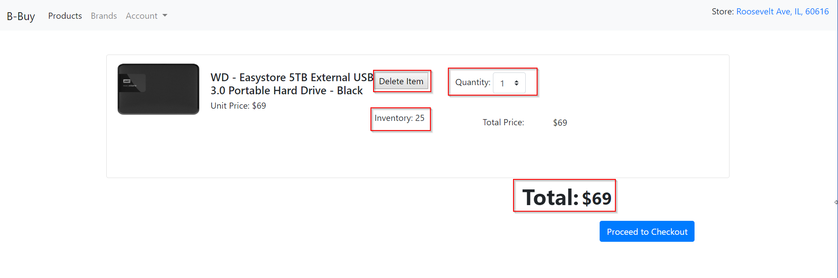

Clicking on proceed to checkout, directly places the order for pickup from selected store

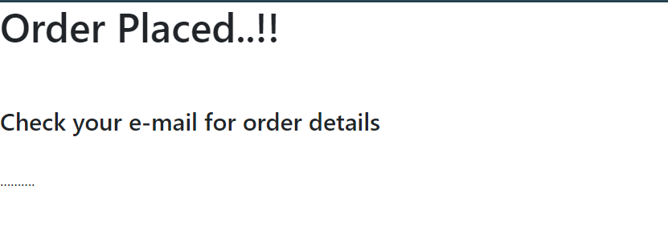

1. If we want to register for an account instead of Guest ordering, we can click on Sign Up, which takes us to the following page:

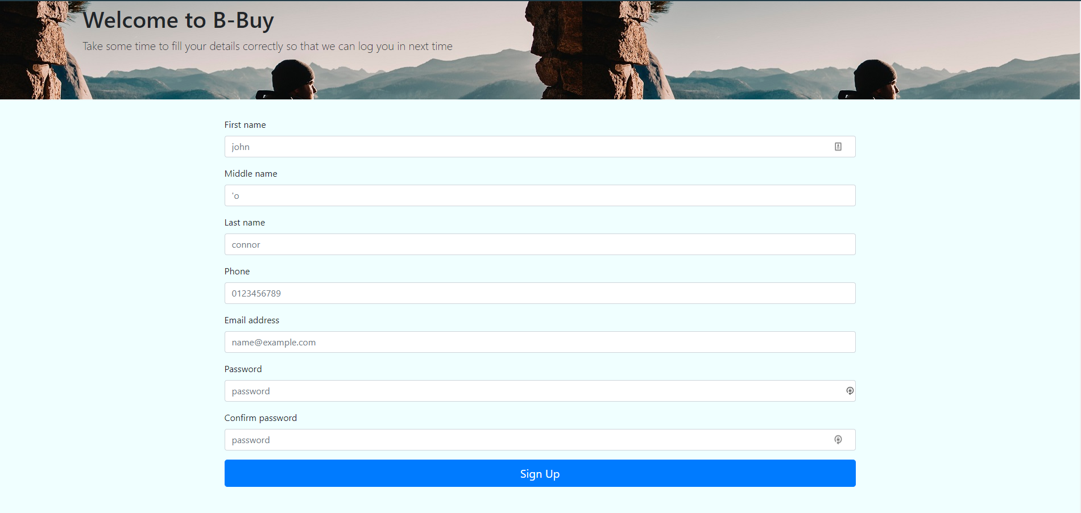

Let us register with a new account:

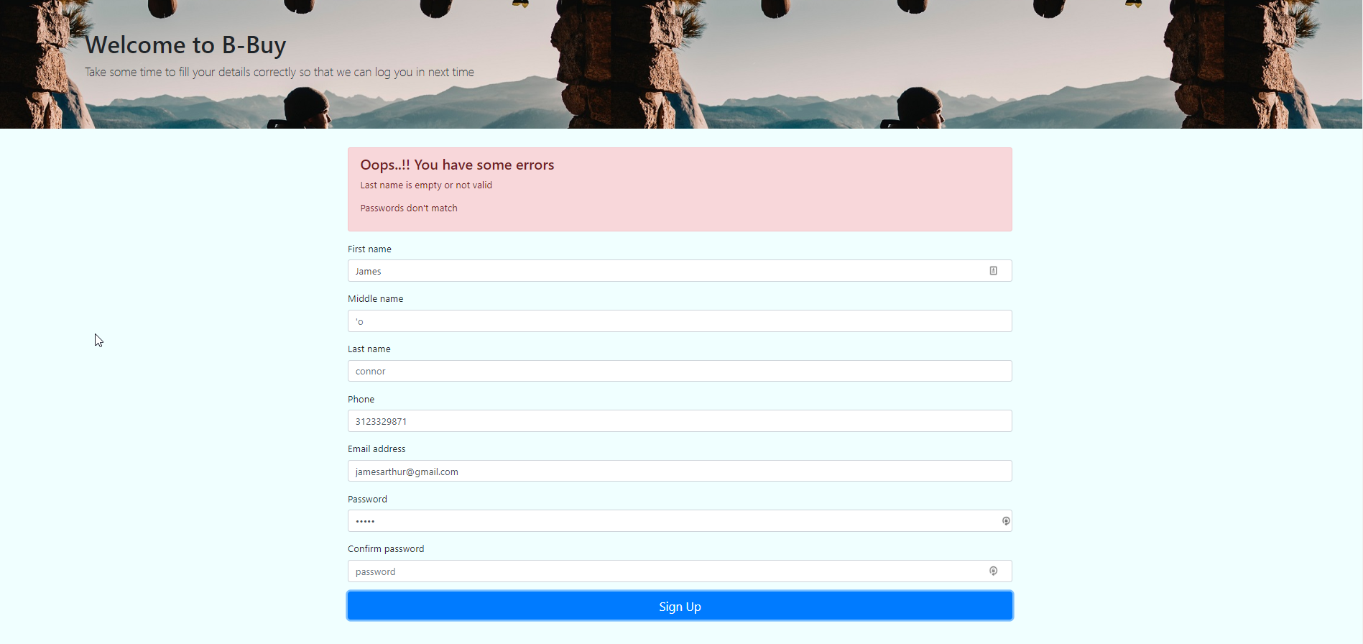

We get errors when the requirements are not met. eg: Here we missed the Last name and no value was entered for the ‘confirm password’ field. Clicking on Sign Up with proper values takes us back to login page and prompts the following message:

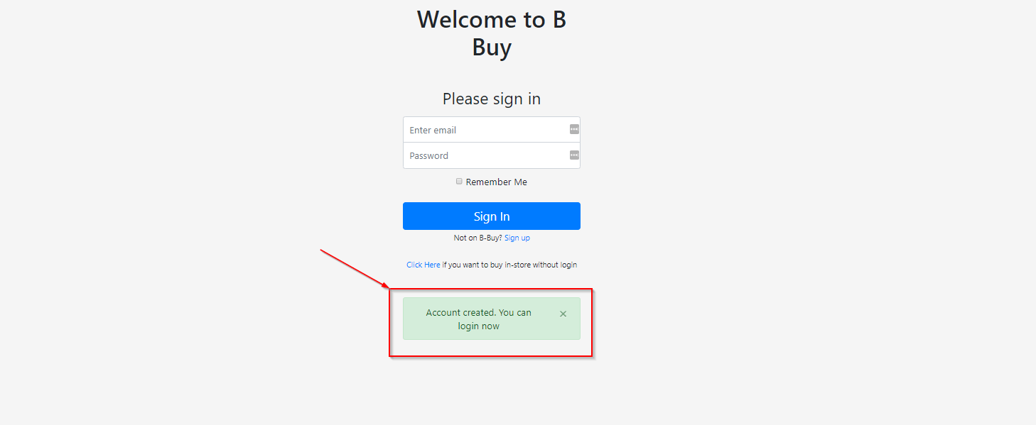

Now let’s check if the user has been created in DB:

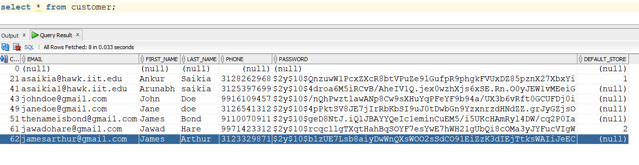

As we can see, a user with **c_id 62** has been created. Now let’s see if we can login:

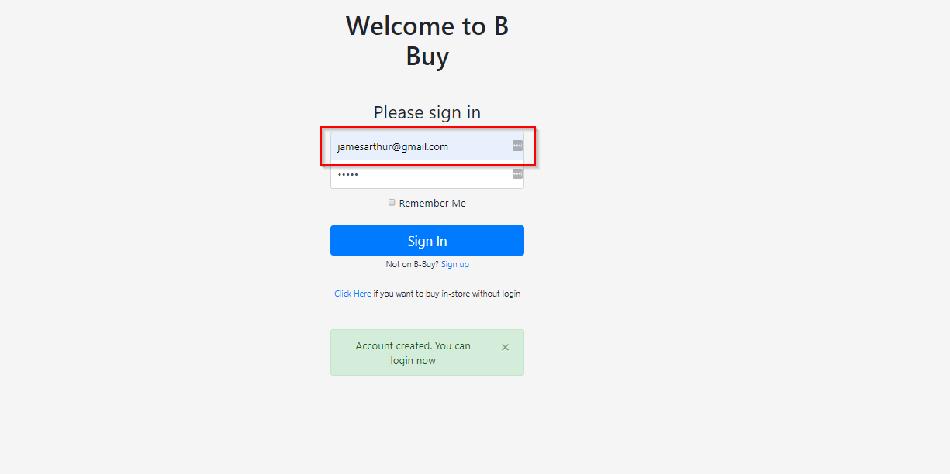

Enter user credentials and click on Sign In:

We have successfully been logged in:

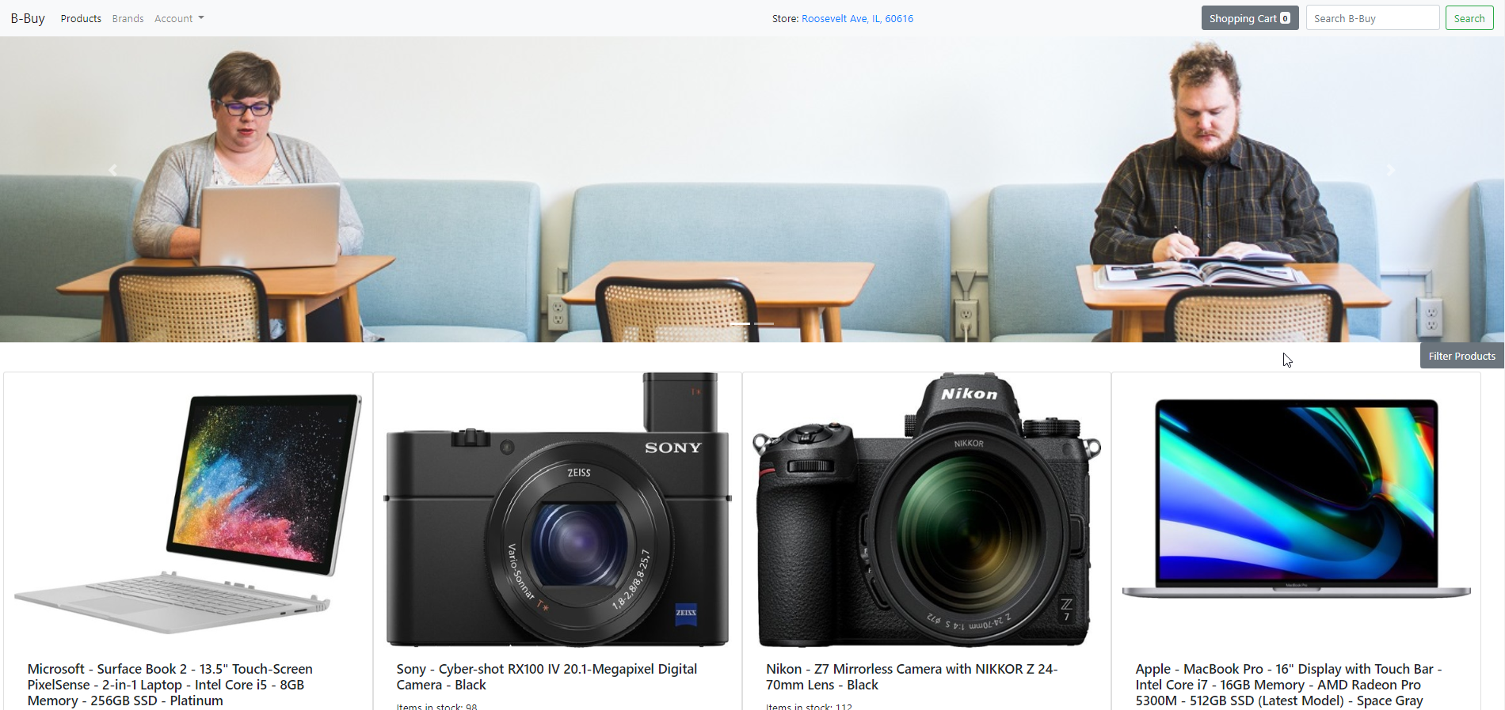

Checking on our DB LOGIN table, we can see the record for this login (for **c_id 62):**

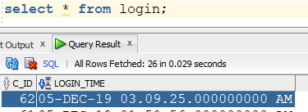

Now we will add a few things to cart:

Search for apple products using search bar:



Clicking on search:

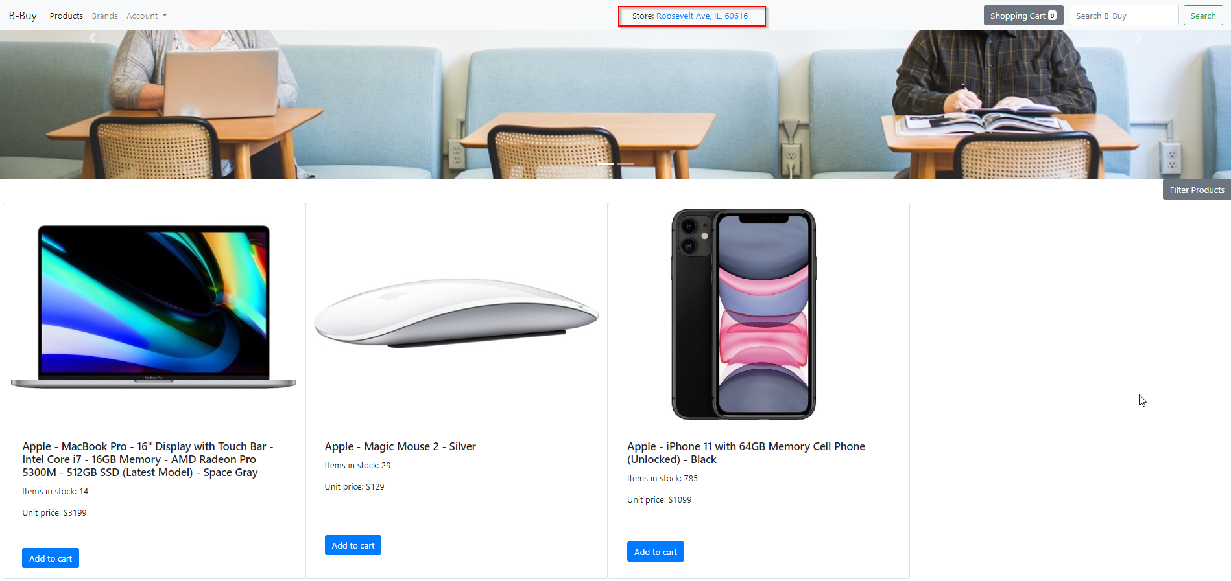

We can also filter products by clicking on **Filter Product** Button:

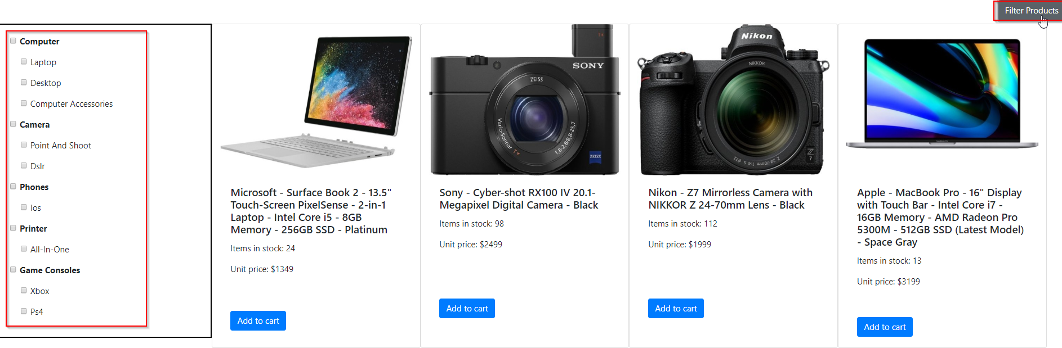

A left pane appears which can be used to filter product by various categories:

Using Subcategory Filter: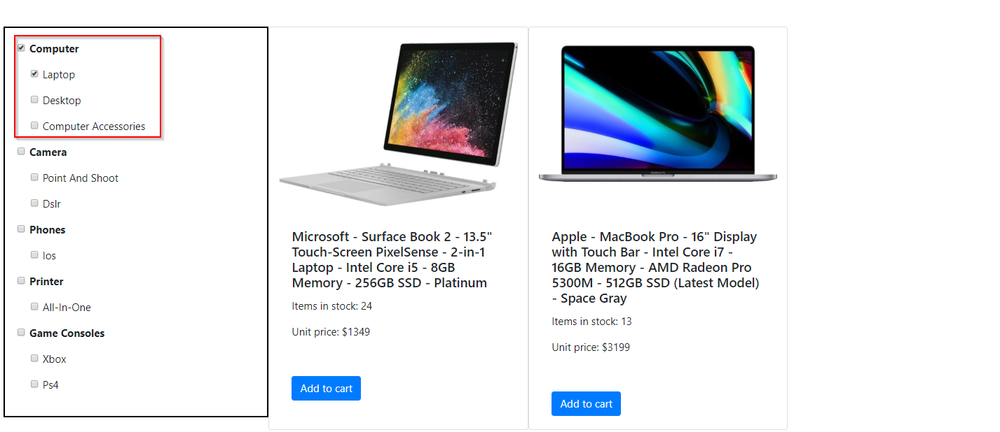

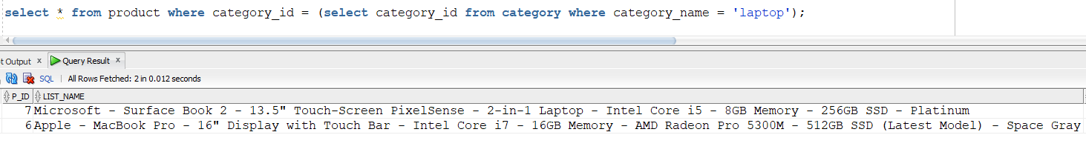

Using Main Category as Filter:

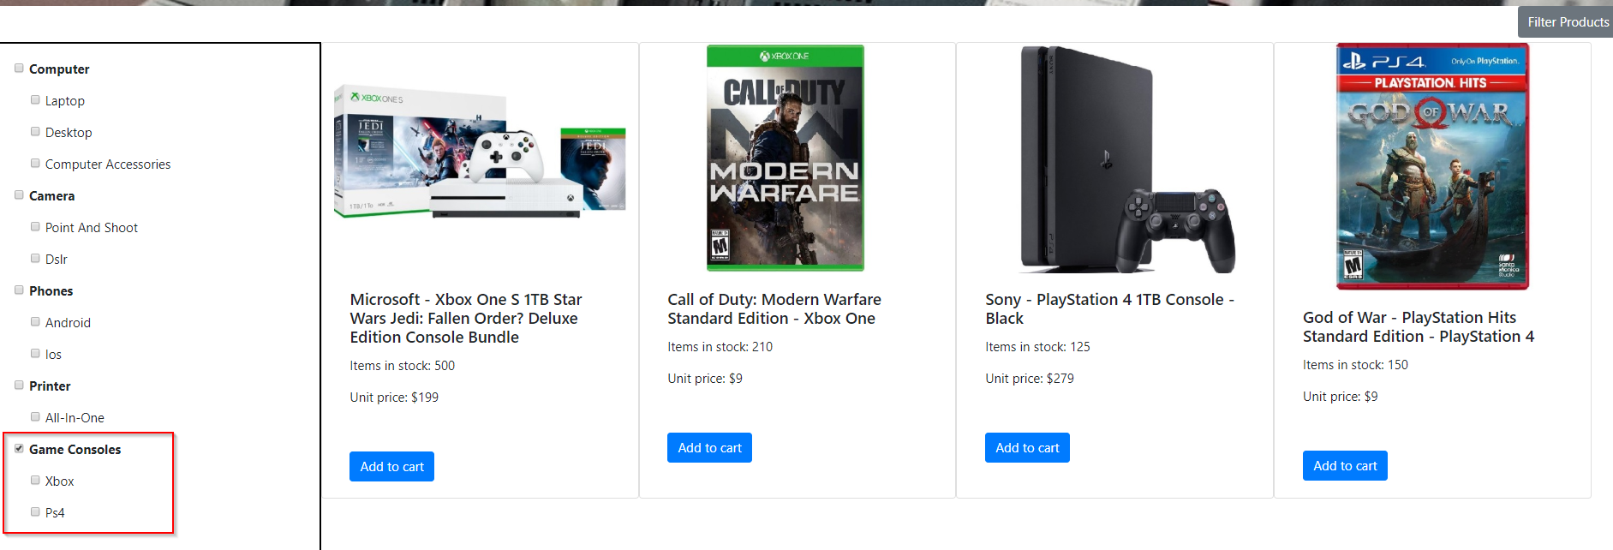

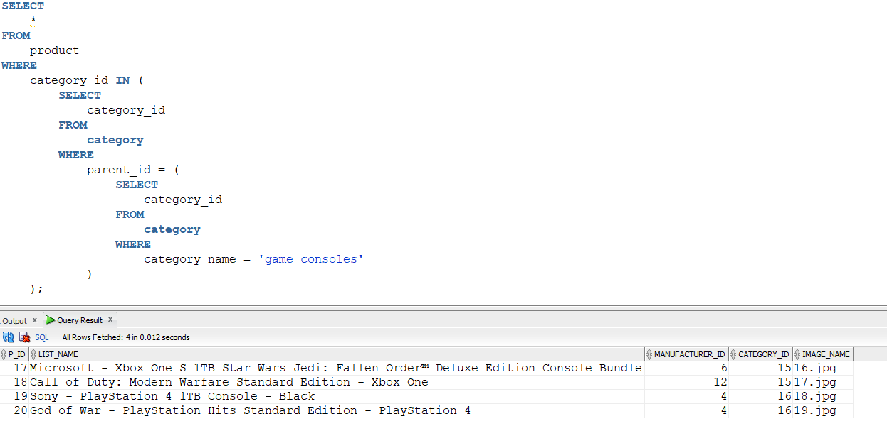

We have 4 available products from the selected store:

Add products and click on CART icon to move to checkout page *(CART icon shows count of items added)*. We can change the quantity of items in cart or even delete any item from the cart.

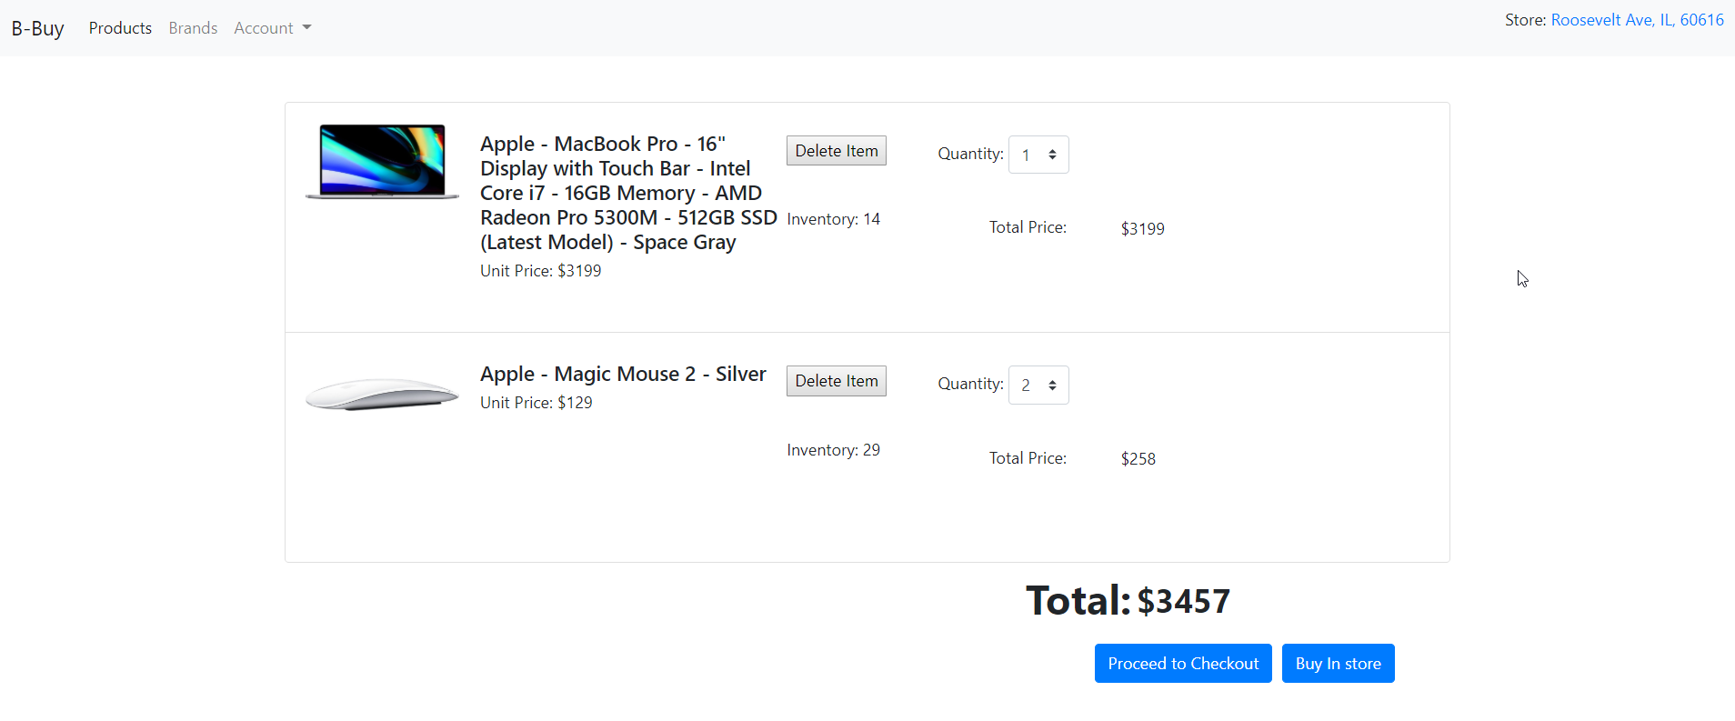

We again have two options: Buy from store or Proceed to checkout, lets use proceed to checkout. **Buy in store** option is for store pickup and **Proceed to checkout** is for home delivery

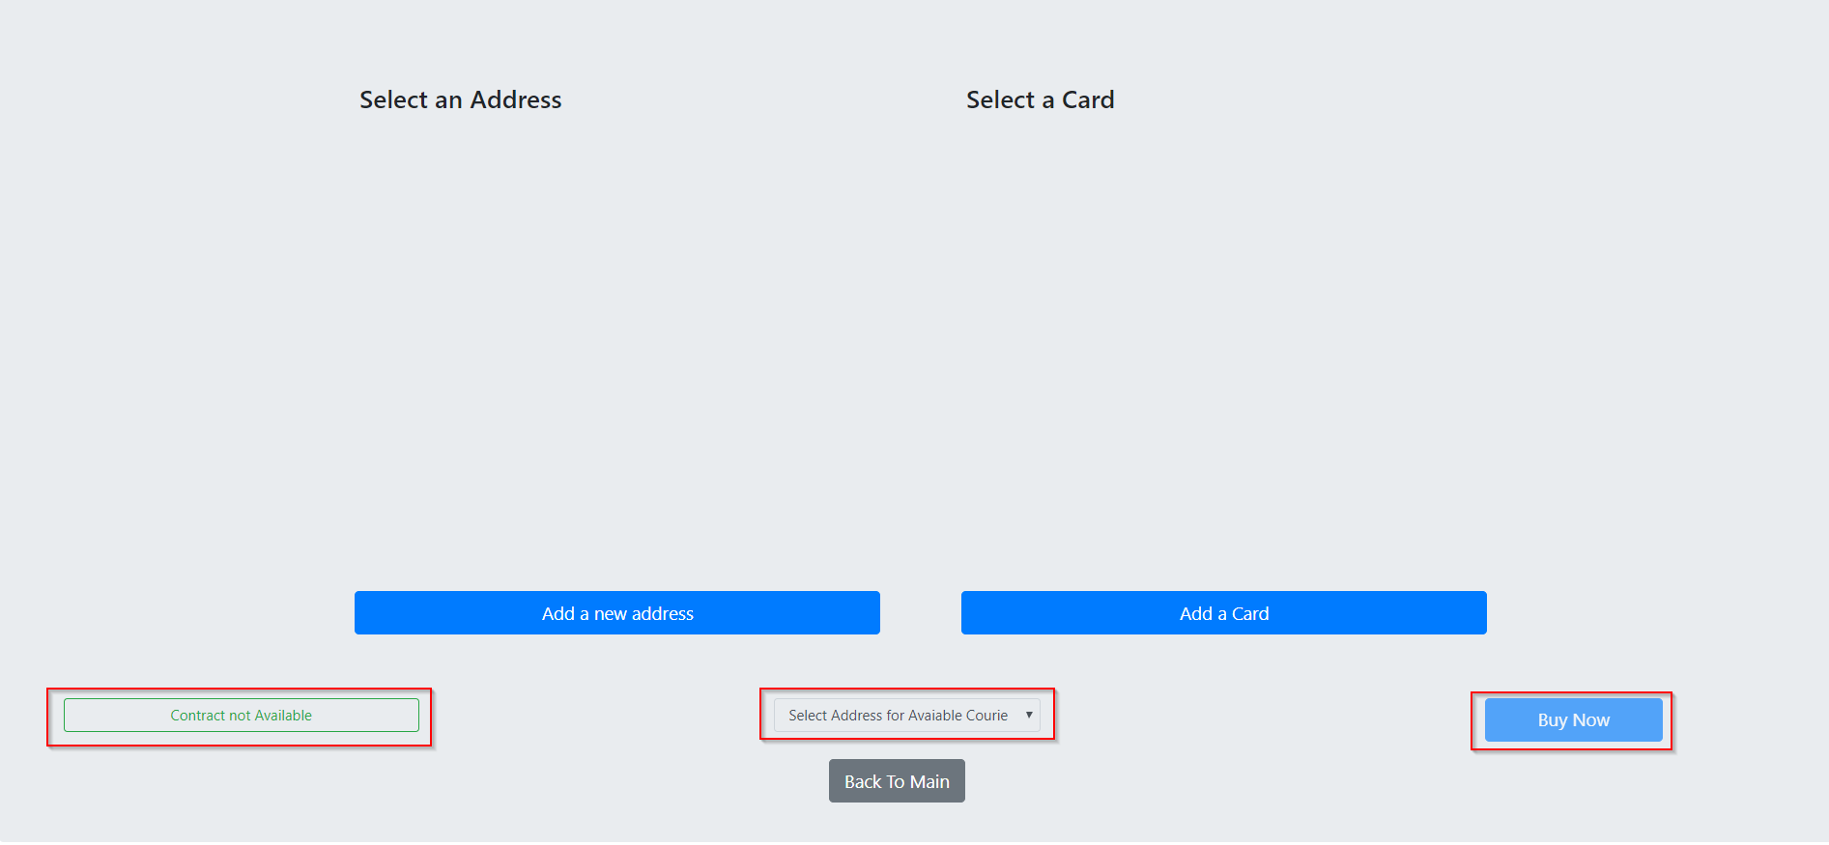

As we have not added any address and payment methods, the Available courier option and BUY NOW option remains unavailable. Also, the customer does not have any available contract

Clicking on Add a new address:

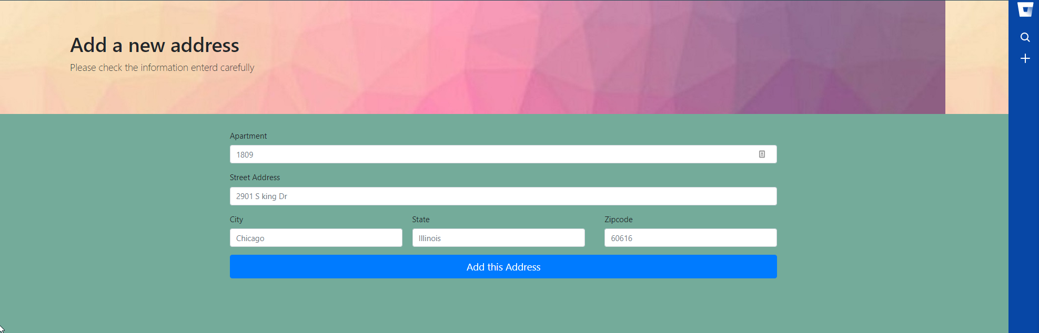

After adding a Valid Address:

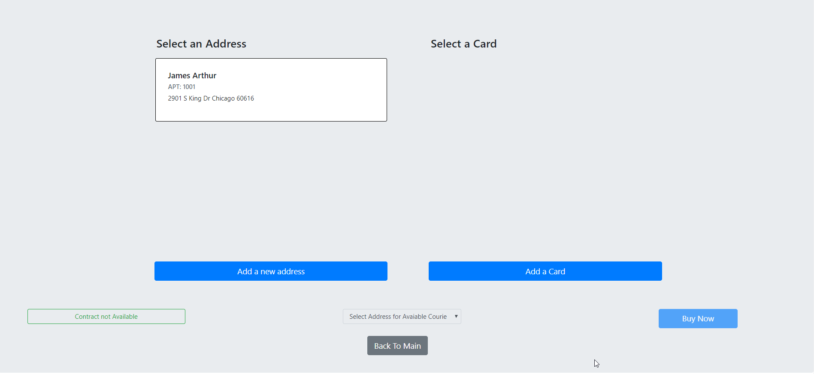

Address is shown for selection. As we have not selected the address, the Courier option is still now shown. Let’s see if added address is inserted in DB table:

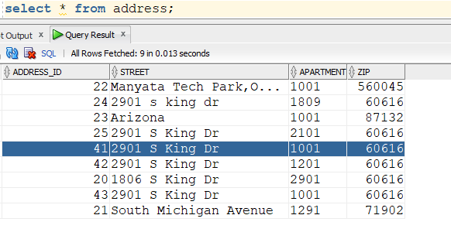

Now select the address and if courier is available for the ZIP, it will show:

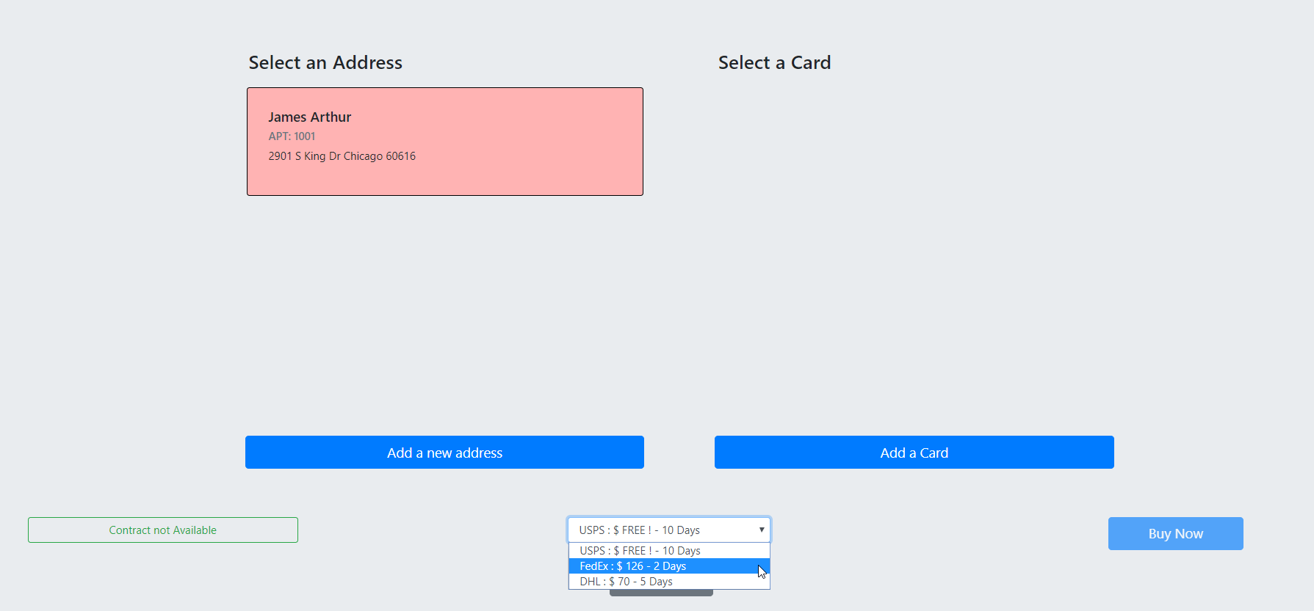

Verify this with DB: available courier for ZIP: 60616

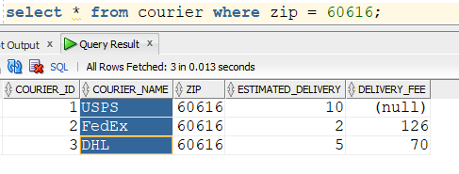

Now we will add a Card and see if BUY now becomes enabled:

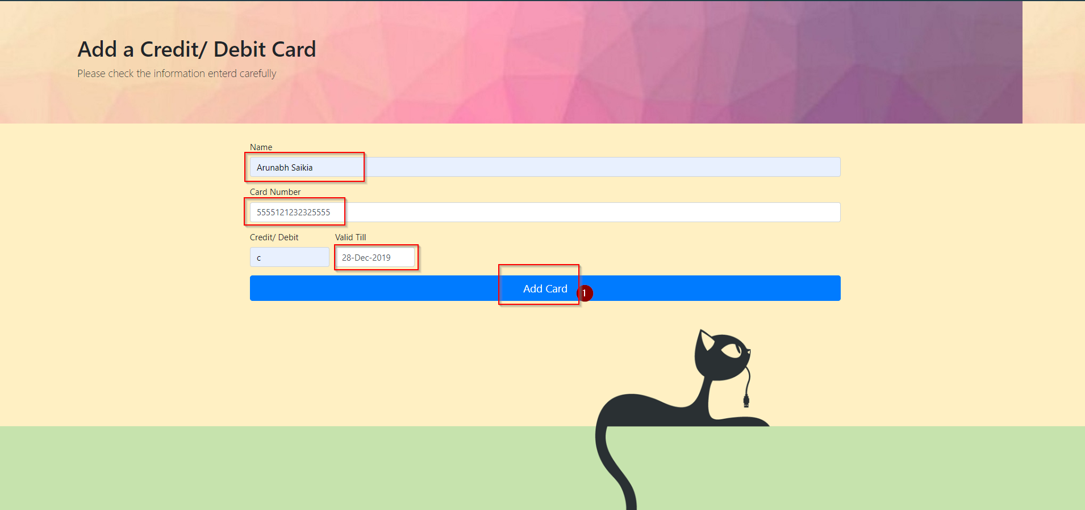

Enter necessary values and click on add card:

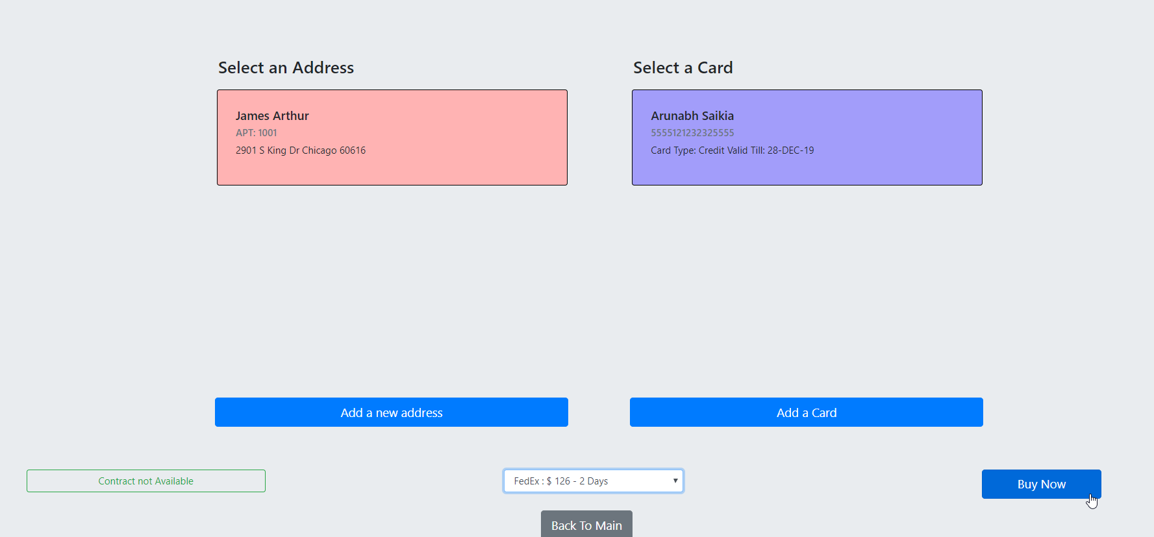

Selecting both address and Card enabled the BUY NOW button. Now click the Buy Now button………..

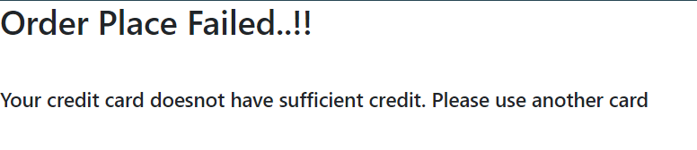

We get the above message on clicking BUY NOW. This is because the CARD we added does not have enough balance. Let’s see from DB:

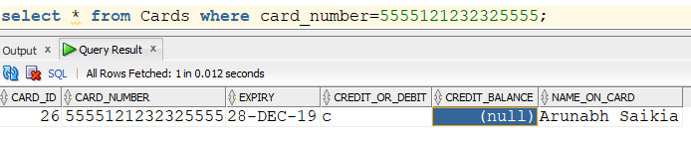

Let’s use a DEBIT card this time:

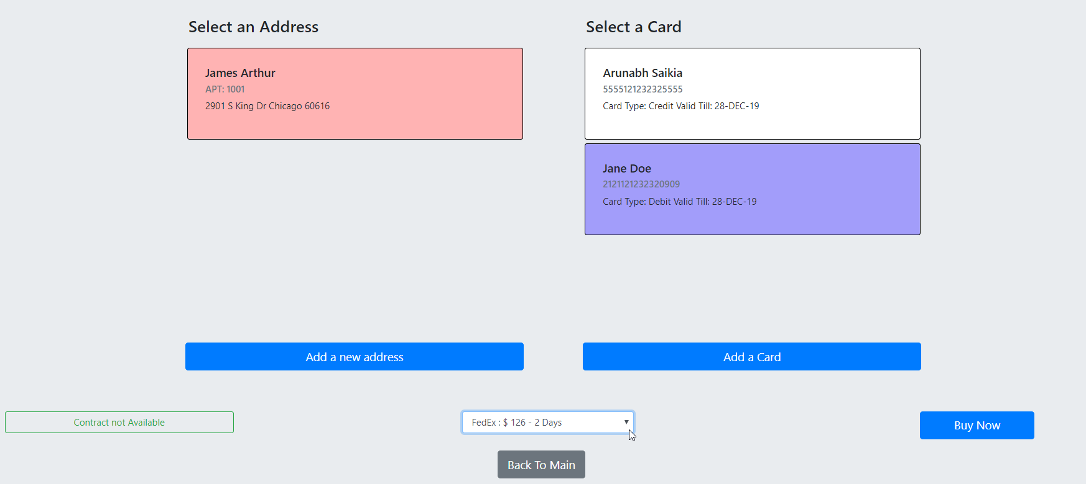

We have selected FedEx USD126 2 Day delivery for this order:

Clicking on buy now gives us the following and redirects us to the Main Page:

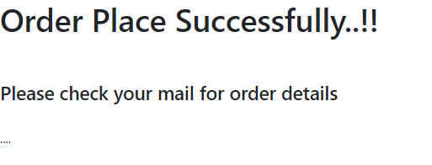

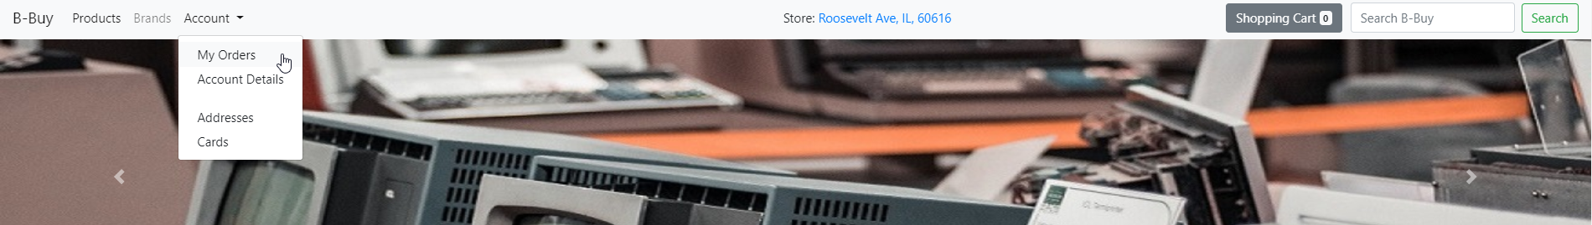

We can go to “**My Orders”** now to see the order details

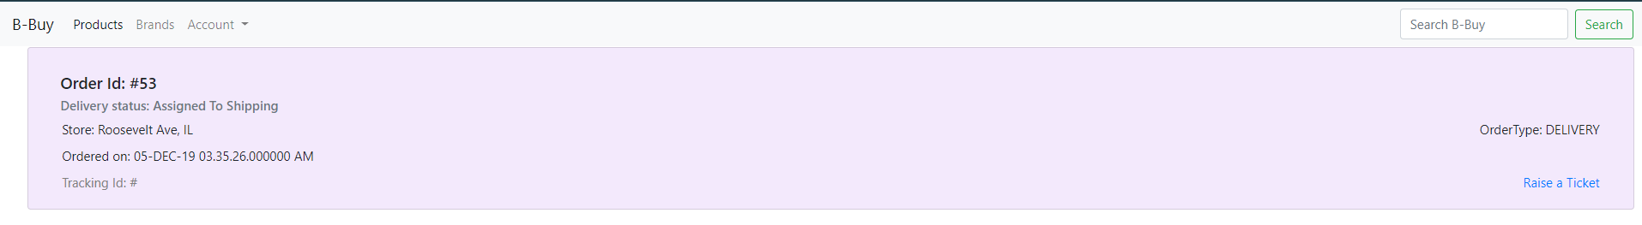

We can see that the order was placed successfully.

From DB we can see all details related to our order as shown below.

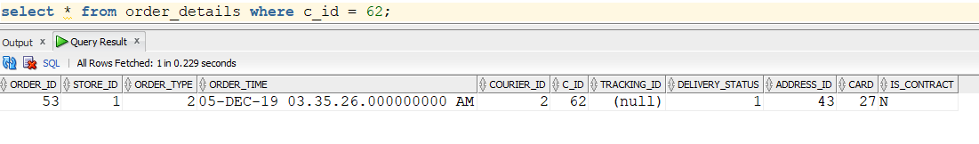

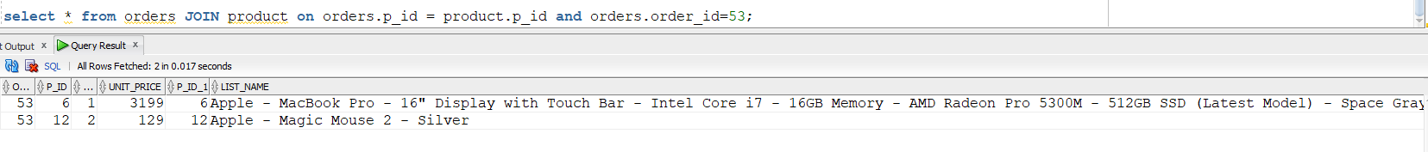

We can also validate the products we ordered, Unit price of each product and the quantity we selected.

Back to our application, we can raise tickets relate to our order by clocking on Account-> My Orders tab from the top bar:

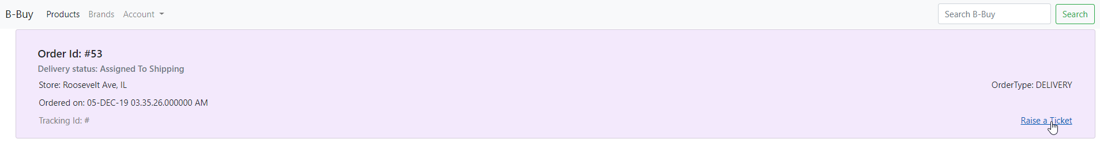

We have successfully opened a ticker for our Order#53

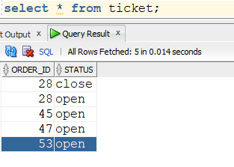

Once the ticket is closed, only then we can raise another one related to order#53.

----------------------------------------------------------X---------------------------------------------------